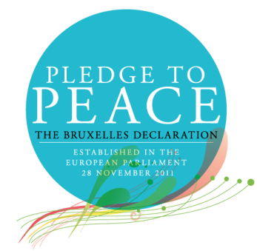
The Oldham Peace Times
Issue 3 – June 2016
News from the Oldham Pledge to Peace Forum

Editorial

Welcome to this third issue of the Oldham Peace Times, newsletter of the Oldham Pledge to Peace Forum. This is a regular publication to inform people and organisations with an interest in working for peace about the Forum and its work.

Peace in Oldham has been given a huge boost by the appointment by Oldham Council of its first Champion for Peace, Councillor Derek Heffernan, as Mayor of Peace. As Oldham’s new First Citizen, Derek will build on the work of his immediate predecessors by promoting peace in our classrooms and communities.

Maria and I recently had the opportunity to meet with the Mayor of Lari and Councillors in Pisa, both signatory towns in Italy, to establish some new friendships for peace. We also attended a number of Pledge to Peace events, including a memorable outdoor concert held in an amphitheatre, hosted under the banner of Palermo for Peace in the regional capital of Sicily.

I hope that this issue will inspire you to do something for peace – you can join the Forum if you represent an organisation that has signed the Pledge to Peace or one that wishes to do so – please find more details on Page 2 and at the end of this newsletter.

Our next newsletter will be out in early September so please send stories, with photos if possible, for inclusion in our next issue, as well as feedback and letters, by email to richardoutram35@gmail.com
Yours in Peace,
Richard Outram,
Editor

CONTENTS
Page 2 An introduction to the Pledge to Peace
Page 3 Mayoral Visit to the Warrington Peace Centre
Page 4 Oldham’s new Mayor of Peace inaugurated
Page 5 Knowsley School says Yes to Peace
Page 6 New friends in Lari
Page 8 And also in Pisa
Page 9 Palermo for Peace
Page 12 UN Peacekeepers’ Day
Page 13 Come and Join Us

An Introduction to the Pledge to Peace
The Pledge to Peace initiative, also called the Bruxelles Declaration, was established at the “Peace and Prosperity - Founding Values of the European Union” conference held on November 28, 2011 at the European Parliament in Brussels.
The initiative was the brainchild of then First Vice President of the European Parliament, Mr. Gianni Pittella MEP, the former President of the European Parliament Senator Emilio Colombo, and the Associazione Percorsi.
The Pledge to Peace was sponsored by Mr. Prem Rawat, an authoritative and international speaker on peace, who was the first signatory. Mr Rawat was later appointed ‘Ambassador to the Bruxelles Declaration - Pledge to Peace’.
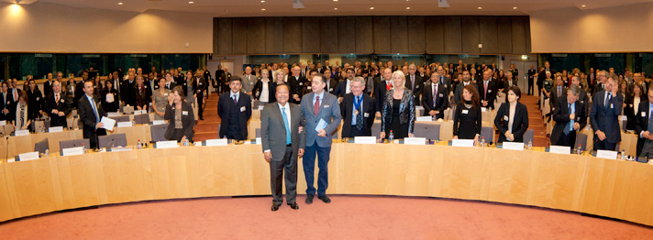
Above: Mr. Prem Rawat and Mr. Gianna Pitella, co-sponsors of the Pledge, in the European Parliament at the conclusion of the conference.
Institutions and organisations are invited to sign the Pledge to help create a “culture of peace” across Europe by carrying out practical actions for peace in their communities. Each signatory is asked to submit a report of these activities to the initiative’s secretariat, the Percorsi Association, by the UN International Day of Peace, observed on 21st September each year.
More information about the Pledge can be found on the following websites:
http://www.pledgetopeace.eu/
http://www.associazionepercorsi.com
More information about the Ambassador to the Bruxelles Declaration – Pledge to Peace, Mr. Prem Rawat, can be found on this website: http://www.premrawat.com

Mayoral Visit to the Warrington Peace Centre

Thanks are due to Nick Taylor, Chief Executive of the Tim Parry Johnathan Ball Foundation for Peace for this article and the photograph.

In February, the (then) Mayor of Oldham, Councillor Ateeque Ur-Rehman, and Mayoress Councillor Yasmin Toor visited the Tim Parry Johnathan Ball Peace Centre in Warrington to promote a campaign for peace. They were joined by Councillor Derek Heffernan, at the time Deputy Mayor, and members of the Oldham Pledge to Peace Forum. Welcoming the Oldham delegation to Warrington were the First Citizen and Mayor Cllr. Geoff Settle and Mayoress Mrs Jean Settle.

Photo: left to right: Colin Parry OBE, Wendy Parry OBE, Mayoress of Oldham Cllr. Yasmin Toor, Mayor of Oldham Cllr. Ateeque Ur-Rehman, Mayoress of Warrington Mrs Jean Settle, Deputy Mayor of Oldham Cllr. Derek Heffernan, Mayor of Warrington Cllr. Geoff Settle, Richard Outram, Foundation trustee and Oldham resident Graham Foulkes, and Maria Ellis.

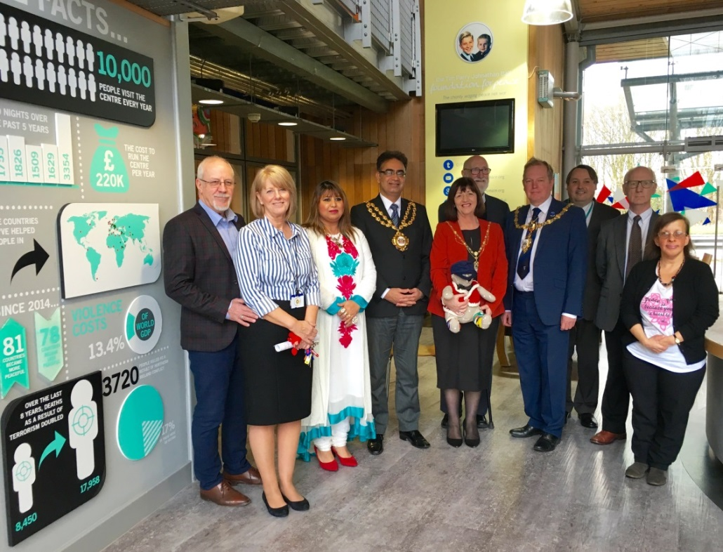

The visit was arranged following the signing of a peace pledge by Oldham Council and the establishment of a Peace Forum within the town. Oldham invited the Tim Parry Johnathan Ball Foundation for Peace, who agreed to join the Council in supporting the pledge, and the visit was organised to celebrate the signing and in a spirit of friendship between the two northern England locations.

The Mayoral party and Oldham peace activists met with the founders of the Warrington based charity, Colin and Wendy Parry, toured the Peace Centre and learnt more about the work for peace carried out by the Foundation.

Mayor Ateeque Ur-Rehman said: “I am absolutely delighted to visit the Peace Centre.

"The threat of terrorism that led to this initiative may no longer exist, but it has taken a new shape and I am pleased that the centre has adapted to the challenge of the new threats of terrorism and extremism and is dealing with this in a totally non-partisan way. Please keep up the excellent work."

Mayoress Cllr. Yasmin Toor said: "Thank you for the invite and for the warm welcome.

"The tour of this wonderful peace building, which is a very powerful symbol of peace and meeting the brave parents and family members who have experienced such a horrible situation but have still decided to spread peace, and spread a message of hope makes them true heroes."

The Foundation works extensively across Greater Manchester and hopes to deliver some of its projects in the Oldham area and in support of the work being led by the Council and the Peace Forum.

To find out more about the work of the Foundation log onto www.foundation4peace.org

Oldham’s new Mayor of Peace inaugurated

On May 18th, peace in Oldham took a great step forward when the Council’s Champion for Peace, Councillor Derek Heffernan became Mayor.

In his acceptance speech, Cllr Heffernan described his inauguration as a “very emotional moment”. Describing his pride at Oldham Council becoming the first UK local authority to become a signatory to the Pledge to Peace and how he felt honoured to be appointed the Council’s Peace Champion, Derek asked to be known as the borough’s Mayor of Peace.

During his term of office, Derek has committed himself to working within the borough to bring the message to the pupils and teachers in our schools that “peace is possible” and more widely “to ensure that Oldham joins with other cities and nations to help create a culture of peace in Europe”.

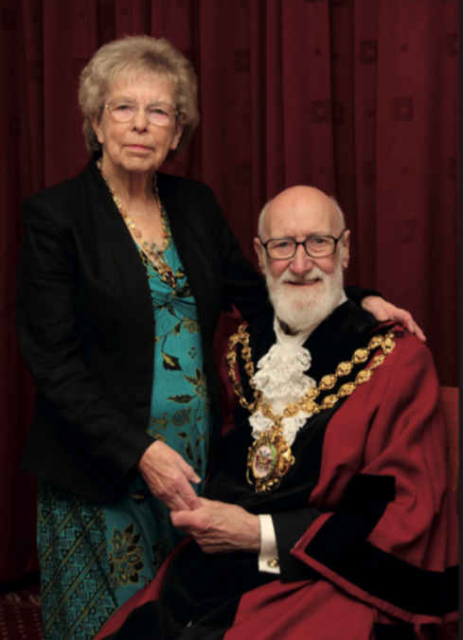 Photo: Oldham’s new First Citizens of Peace

Over the next year, the Oldham Pledge to Peace Forum will be working closely with our new First Citizens, the Mayor and Mayoress, Derek and Di Heffernan, to make Derek’s vision a reality and Oldham an exemplar borough for peace.

Knowsley School says Yes to Peace

One of the first acts of our new Mayor of Peace was to arrange a visit to the junior school of which he is the Chair of Governors, Knowsley in Springhead.

The staff and pupils were delighted to welcome the Mayor and the Youth Mayor Saskia Edwards to their assembly. When asked by the Mayor whether they wanted the school to sign the Pledge to Peace, 350 voices shouted in unison ‘Yes’!

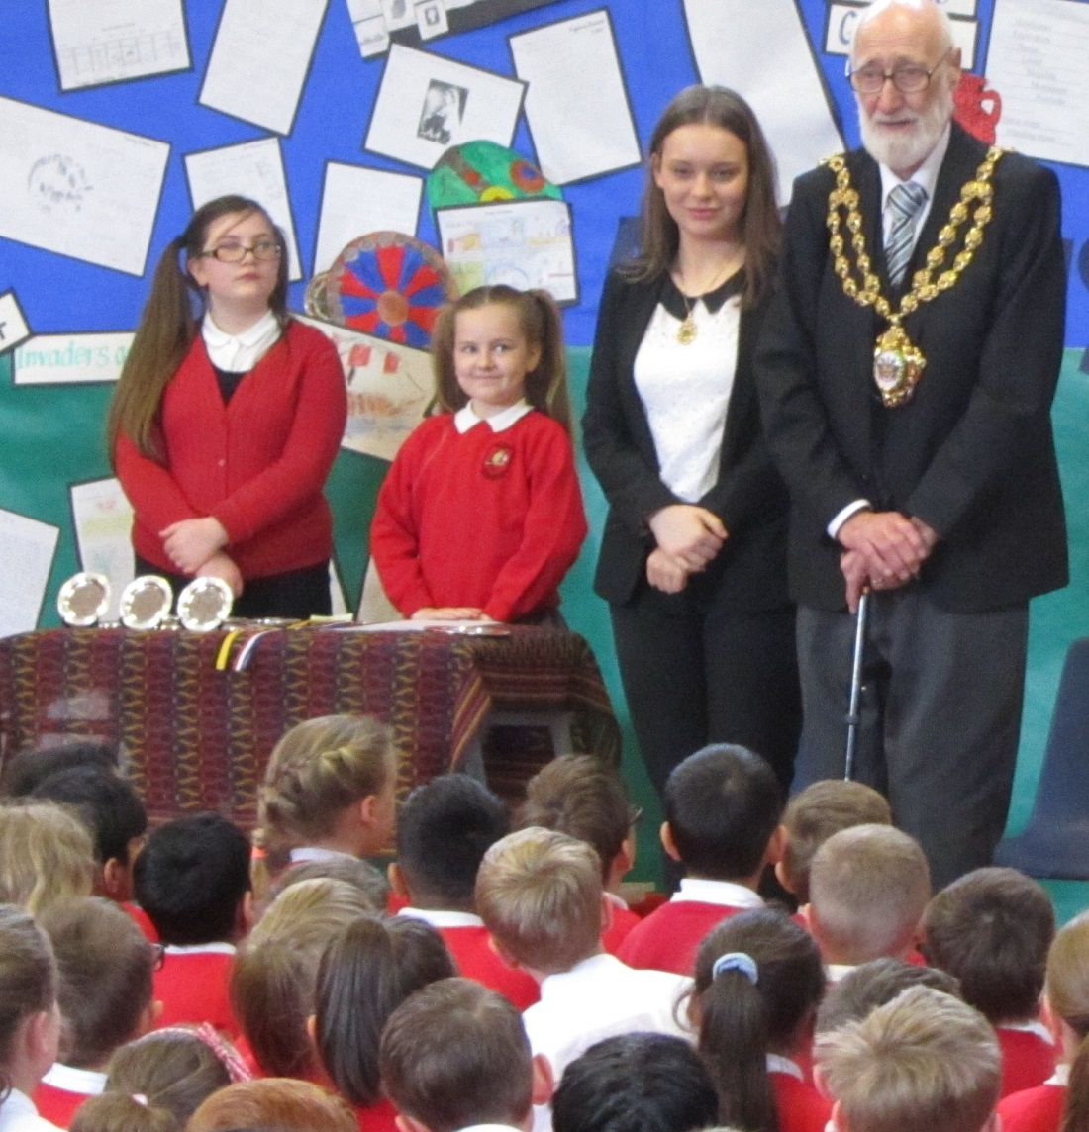

Photo: The Mayor of Peace, accompanied by the new Youth Mayor, addresses the children of Knowsley School at the assembly

Nikki Haslam, one of the teachers who will be taking a lead in introducing the Pledge at the school, commented:

“It was so lovely that the Mayor chose to visit us in an official capacity last week, the children loved the presentation. We are all very proud that, not only is he now Oldham's Mayor of Peace, but he is also our Chair of Governors.

“As a Rights Respecting School we believe that everyone in the world has the Responsibility to make our world a Peaceful World. We celebrate and respect different cultures and diversity at Knowsley and we have played our part in the Peace Ceremony that happens in Oldham on an annual basis.

“Many congratulations from everyone at Knowsley!”

Knowsley Junior School becomes the fourth school in Oldham to sign the Pledge to Peace and our new Mayor has made it a personal priority to sign up many more during his year in office!

Thanks are due to Nikki for the photo.

New Friends in Lari, Italy…

In late May, Maria and I had the great privilege to meet with the Mayor and the Councillor for Culture and Peace in Lari, a small hill village located above the dazzlingly beautiful Pisan plain in Tuscany.

Photo: Lari view from above

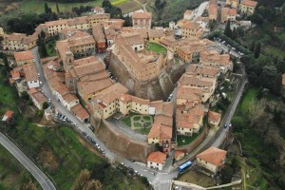

Lari was one of the very first municipalities to sign the Pledge to Peace in 2011.

The arrangements for the visit were made with the kind assistance of our friends at the Percorsi Association, Anna Arrighi and Alessandro Biagioni.

Maria and I had come to the village to forge links of friendship between the Mayor, Council and People of Oldham and those of the municipality.

We were warmly received by Mayor Mirko Terreni and Councillor Chiara Ciccare.

Before the meeting, Chiara kindly gave us a tour of the medieval village with a visit to an artisan pasta maker established in 1926, a chance to take in the breath-taking views from the castle walls, and an opportunity to eat cherries from the tree in the town hall garden!

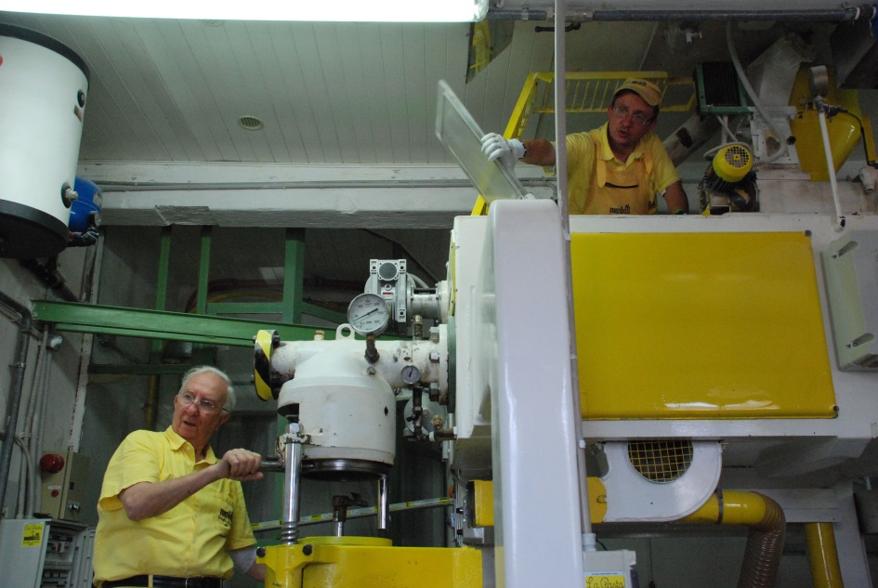

Photo: Members of the Martelli family hard at work producing the pasta (And no they are not the Super Mario brothers)

At the meeting Richard read a letter of friendship from our new Mayor of Peace and Maria presented the Mayor of Lari with a gift of the coat of arms of Oldham. In return we received several gifts to bring back to the Mayor of Oldham.

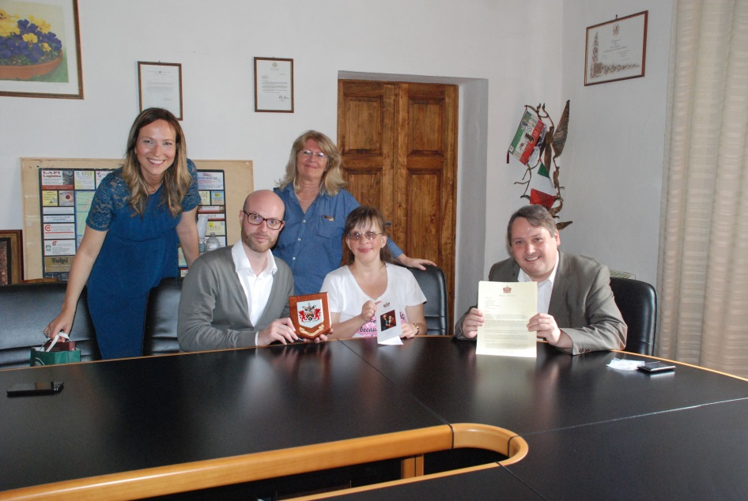

Photo: Left to Right: Councillor Chiara Ciccare, the Mayor of Lari Mirki Terreni, Anna Arrighi from the Percorsi Association and Maria and Richard

And also in Pisa…

On the following day, thanks again to Anna and Alessandro, we were also able to meet with two senior Councillors, Marilu Chiofalo and Danielle, who lead on culture, education and peace within the cabinet of the Mayor of Pisa. Unfortunately the Mayor was unable to attend due to another engagement.

Danielle first kindly offered us a personal tour of the restored ornate ceremonial rooms in the city hall.

As at Lari, Richard read out a letter and Maria made a presentation of a gift. In return, we received gifts to bring back to the Mayor of Oldham.
From our discussion, it is clear Pisa has a comprehensive peace programme in place particularly around school and youth engagement [Pisa has the largest student community in Italy], upholding women’s rights, supporting asylum seekers and providing humanitarian assistance to projects in conflict zones.
We had an in-depth discussion to identify areas where we might link our work in practical ways by using electronic media to exchange news and by establishing direct school-to-school links. Colleagues in Lari were also keen on this.
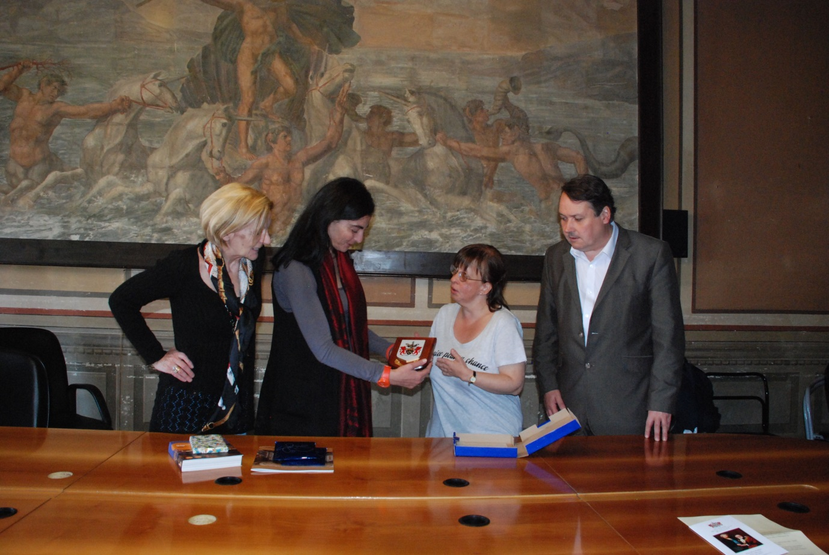

Photo: Danielle and Marilu accept the gift on behalf of the Mayor of Pisa from Maria

Palermo for Peace
After the success of the Peace Celebration held in Segesta, Sicily last summer, the Percorsi Association and Italian partners organised a number of peace events hosted by the city of Palermo, a signatory to the Pledge to Peace, in late May and early June.
Maria and Richard represented the Oldham Pledge to Peace Forum at:
- A Hospitals for Peace event at the Presidio Ospedaliero ‘Vincenzo Cervello’. This city hospital has recently signed the Pledge to Peace as part of the Medicines for Peace initiative. The Ambassador of the Pledge to Peace, Mr Prem Rawat, was the keynote speaker at the healthcare conference held on May 31st. Maria managed to say ‘hello’ with Mr. Rawat as he was leaving the event.
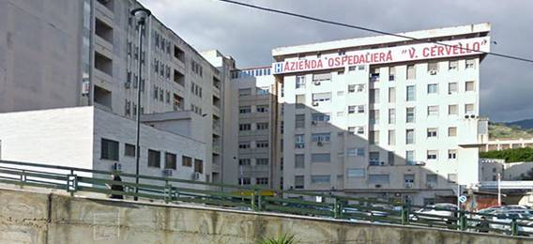
- The 1st June launch at the University of Palermo of the new Media for Peace initiative, organised and promoted by the Journalists’ Association of Sicily.

The initiative aims to encourage media outlets to become signatories to the Pledge and to commit themselves to bringing the topic of peace to the attention of the public.

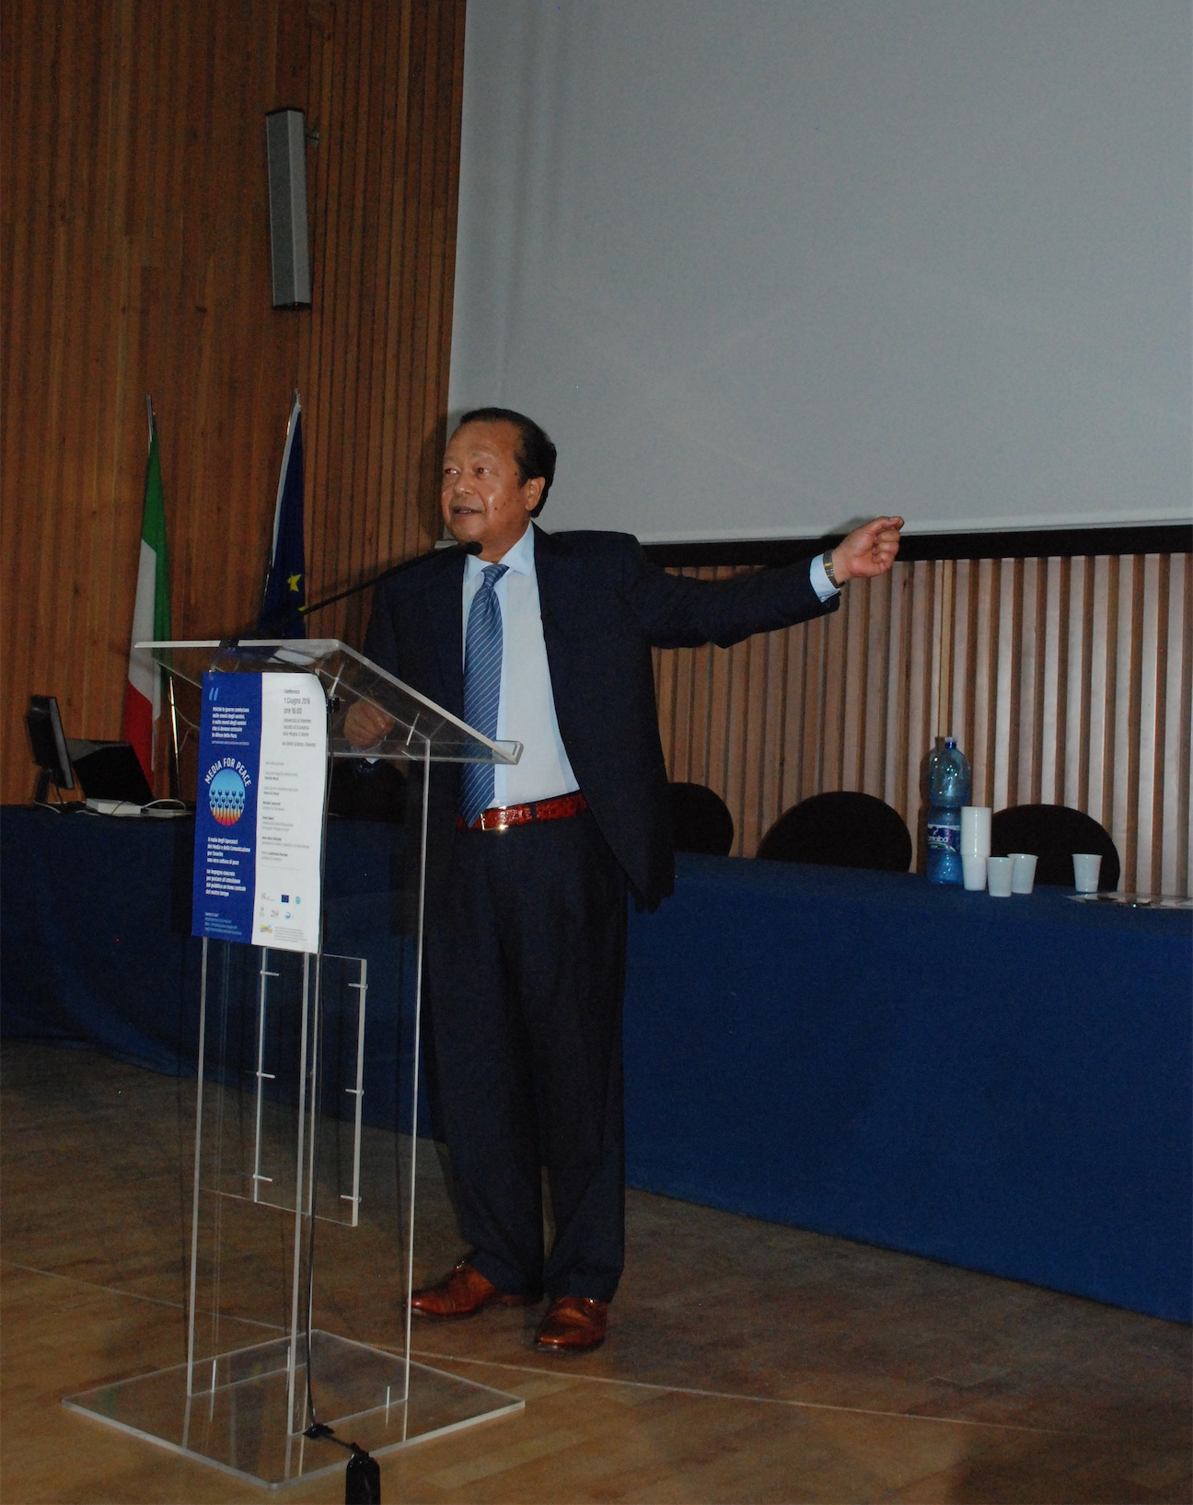
Photo: The Ambassador to the Pledge to Peace, Mr. Prem Rawat, speaking at the Media for Peace event
- An outdoor event held on the evening of 4th June at the historic outdoor Teatro della Verdura. This event Palermo for Peace was dedicated to peace, with music from a variety of artists, a very moving reading about asylum seekers, and a keynote speech from Mr Prem Rawat.
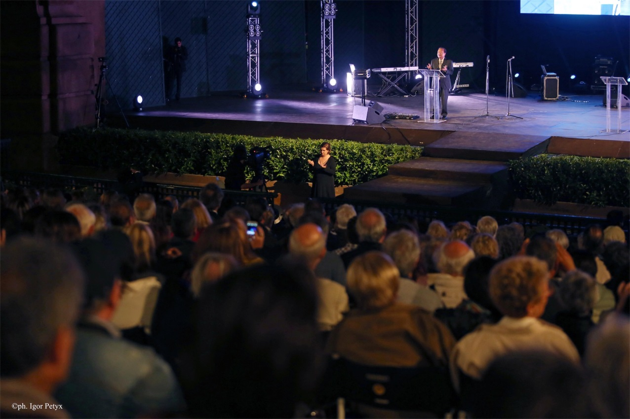
Photo: Keynote speaker Mr. Prem Rawat addressing the Palermo for Peace event
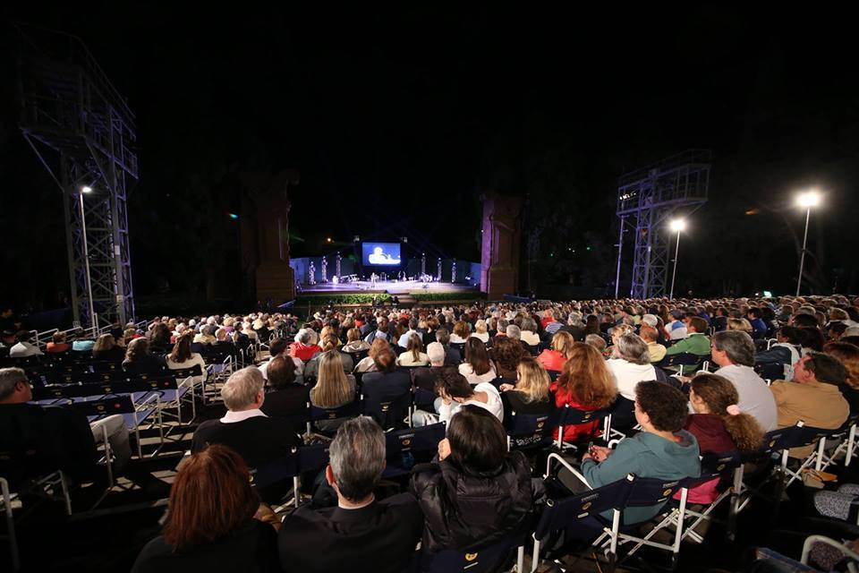
Photo: The view over the audience
Thanks are due to Alessandro Biagioni from the Percorsi Association for the photos of the events in Lari, Pisa and Palermo.

29 May International Day of United Nations Peacekeepers
In 2002, the UN designated an annual day to honour the UN peace-keepers who have lost their lives in the cause of peace and to pay tribute to all the men and women who have served, and continue to serve, in UN peacekeeping operations around the world for their high level of professionalism, dedication and courage.
Since the first UN peacekeeping mission was established in 1948, 3,454 military, police and civilian personnel have lost their lives in the service of peace as a result of acts of violence, accidents and disease.
The UN has so far established 69 peacekeeping operations – in Africa, the Americas, Asia, Europe and the Middle East. The number of people who have been UN peacekeepers — more than 1 million — far surpasses the total number of staff who had worked for the UN in all other capacities worldwide.
Today, some 123,000 women and men from 124 countries serve in 16 peacekeeping missions in some of the world's most challenging and austere environments and mandated with increasingly complex and difficult tasks.
In London, the United Nations Association – UK, in conjunction with UNA - Westminster and the Royal United Services Institute, hosts one of the largest memorial services in Europe. Every year, to honour the day, Whitehall is closed off and a memorial service is held at the cenotaph to commemorate those men and women who have lost their lives in the service of peace.

This year, the event was hugely successful. The Whitehall area was packed with attendees and over 100 diplomatic representatives laid wreaths for peacekeepers. The ceremony was accompanied by a high-level conference on Peacekeeping.

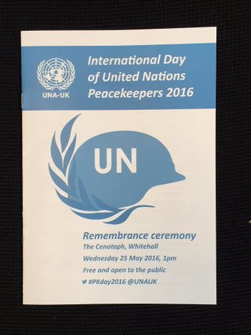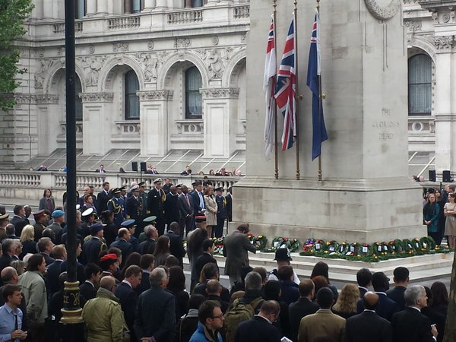

Photos: Publicity poster and the 2016 event at the Cenotaph, Whitehall

You can find more information about the peacekeeping memorial service on the UNA – UK website at: http://www.una.org.uk/news/16/05/una-uk-unites-98-countries-commemorate-un-peacekeepers-day.

Come and Join Us
The next meeting of the Oldham Pledge to Peace Forum will be held on Friday 8th July 2016 from 10.30am until Noon in the Training Suite at Action Together, 12, Manchester Chambers, West Street, Oldham OL1 1LF.
Please note the change of venue for this meeting. Capacity is quite limited so confirmation of your attendance will be appreciated.
Institutions, organisations and individuals who support the work of the Forum, and / or wish to sign the Pledge to Peace, are welcome to attend.
For further details about the event or any of the contents of this newsletter, please contact Richard at The Oldham Pledge to Peace Forum by email to richardoutram35@gmail.com or telephone 07583097793
Thank you for your interest.

